1. **Write a PL/SQL block to print “Hello world”. Also add two numbers(take user input) and print the result.**

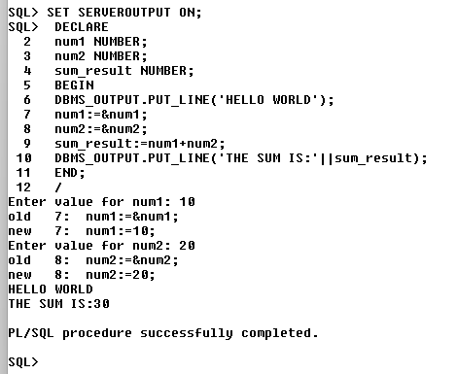

1. **Create a table named CUSTOMERS having the following attributes ID,NAME,AGE,ADDRESS and SALARY. Write PL/SQL code to assign data of a customer having id 1 into PL/SQL variables and then display it.**

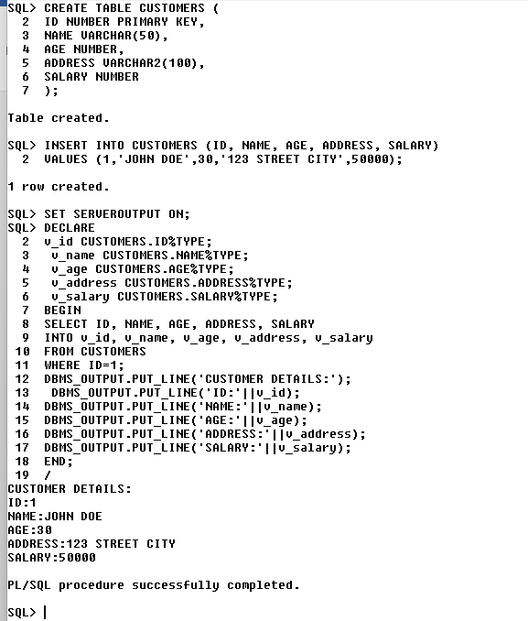

1. **Create a table named Employee having the following attributes E_ID,FNAME,LNAME,SALARY and D_ID.**

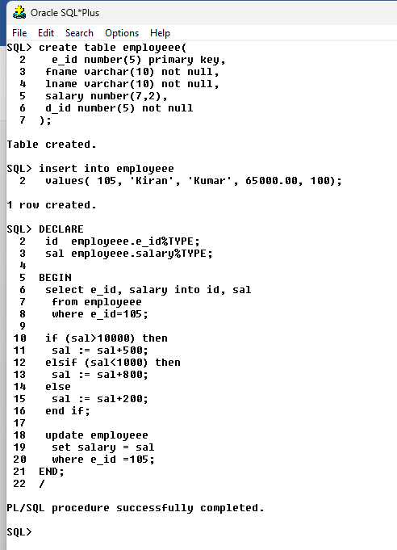

**4. Create a PL/SQL code block to calculate the area of a circle for a value of radius varying from 3 to 7. Store the radius and the corresponding values of calculated area in an empty table named Areas, consisting of two columns Radius and Area.**

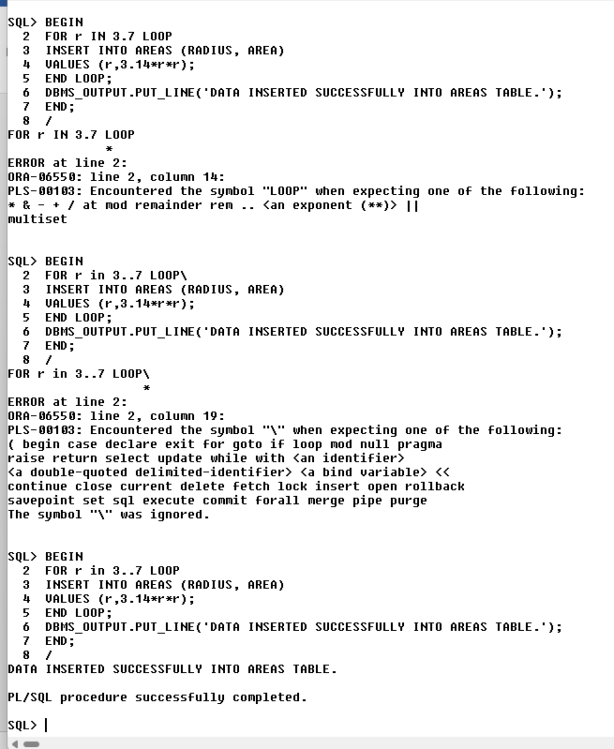**­**

**5. Create a PL/SQL block to take a limit from the user and print from 0 to that limit in both ascending and descending order. Create a relation named Numbers(Ascending,Descending) and add data into that table.Use appropriate loop structure**

